Project name : Bus Booking

Languages used : Python, Flask

Database : MySQL

Documented By : Rajesh(17E235)

Home Page :

1. Admin Login – Default login id : username=Rajesh and password=1234

2. Agent Login

3. Exit

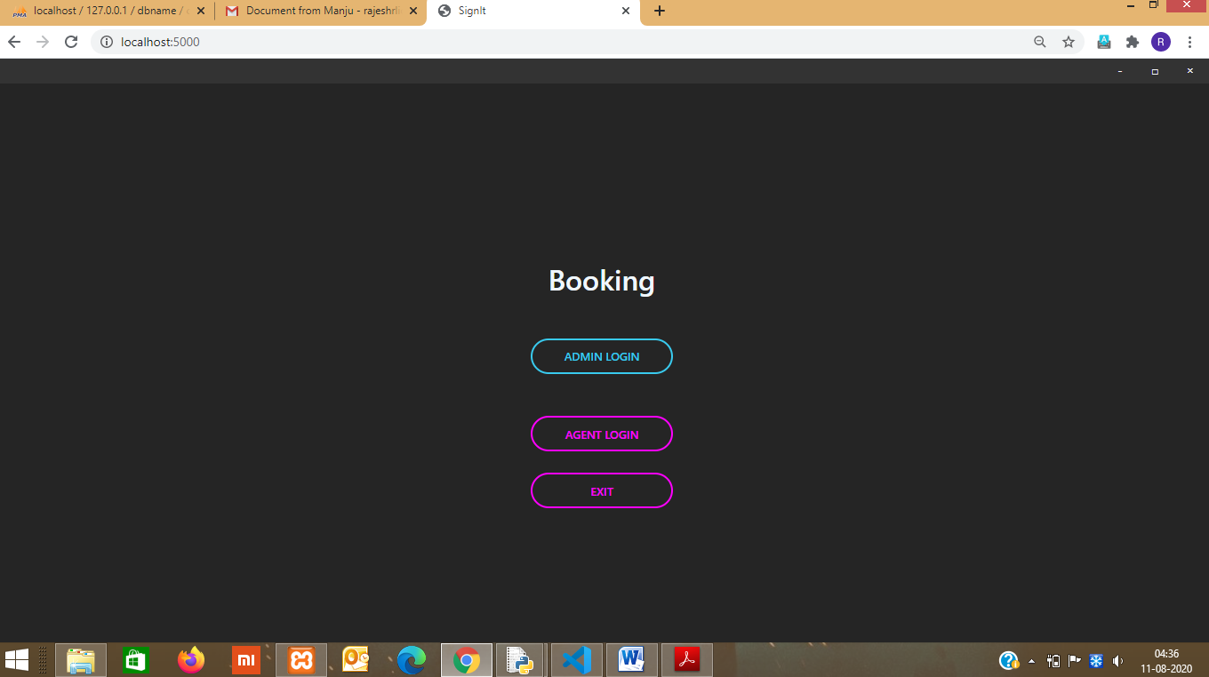

Admin login details validation:

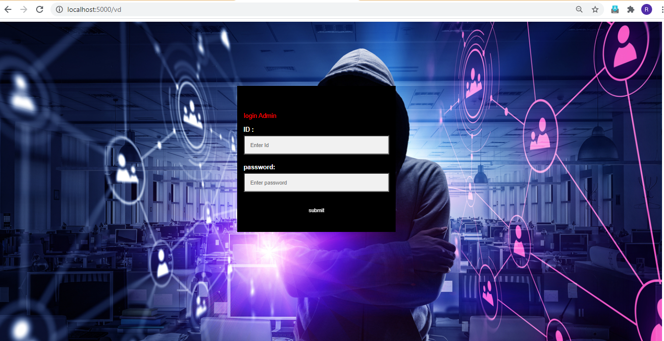

If Admin login details is invalid, an error throws:

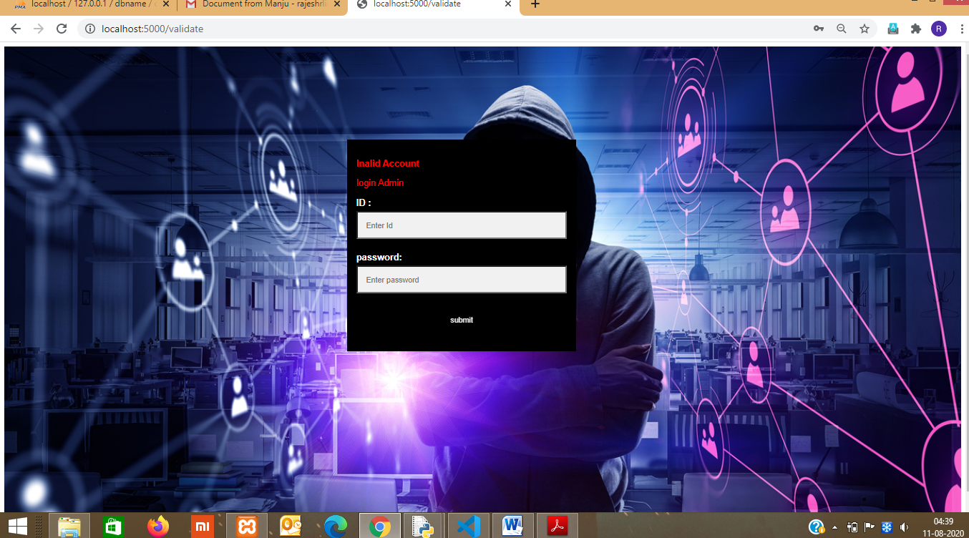

On successful login, goes to Admin page

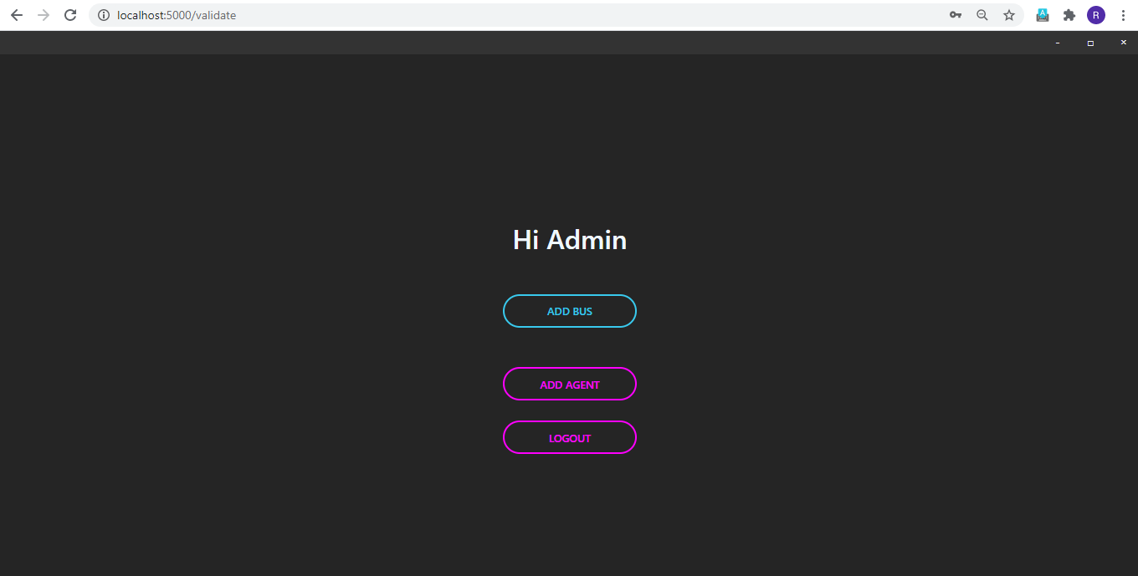

On clicking Add bus page, navigates to Add bus page

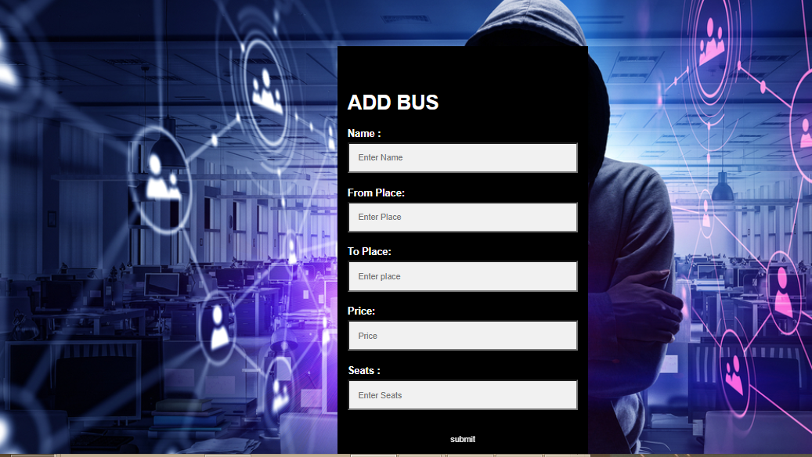

On Adding bus details, Bus details are shown with auto generated bus id



DB details:

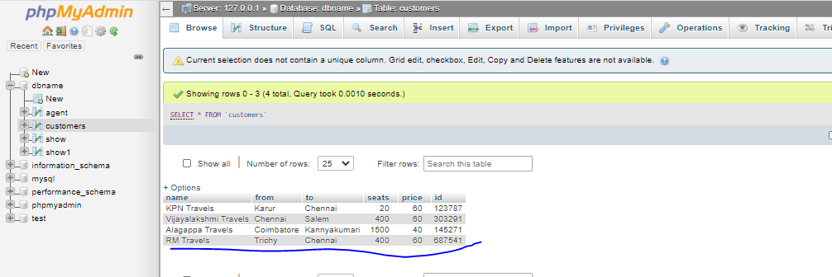

Add Agent Login details page:

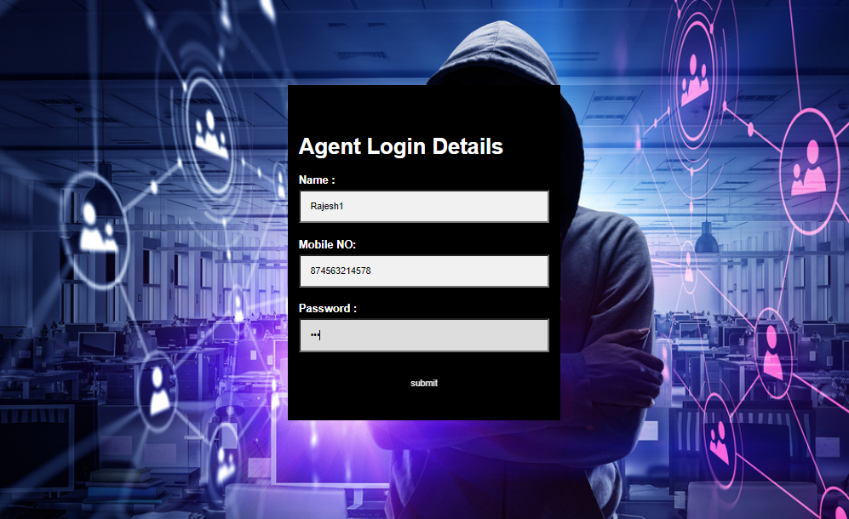

Agent added successfully as:



Db details:

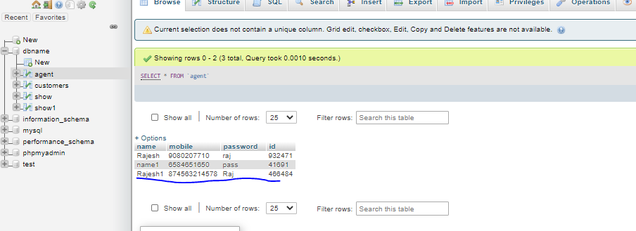

On Logout goes to Home page

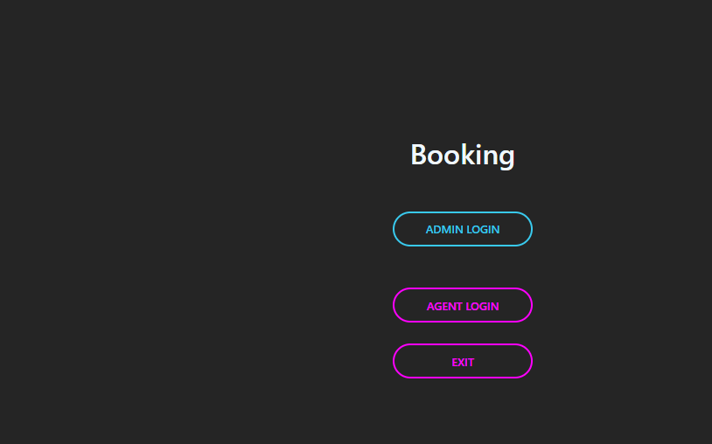

Agent details is incorrect, throws validation error as:

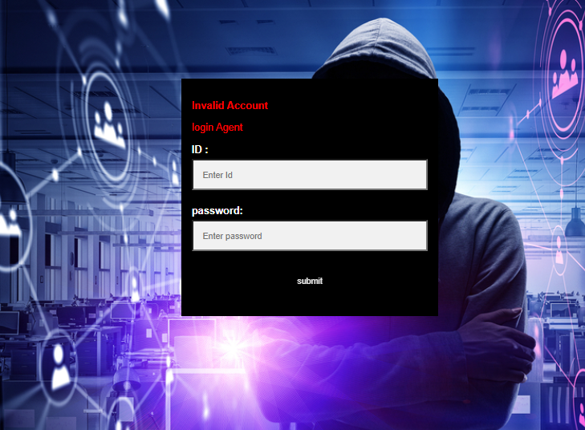

On successful Login, 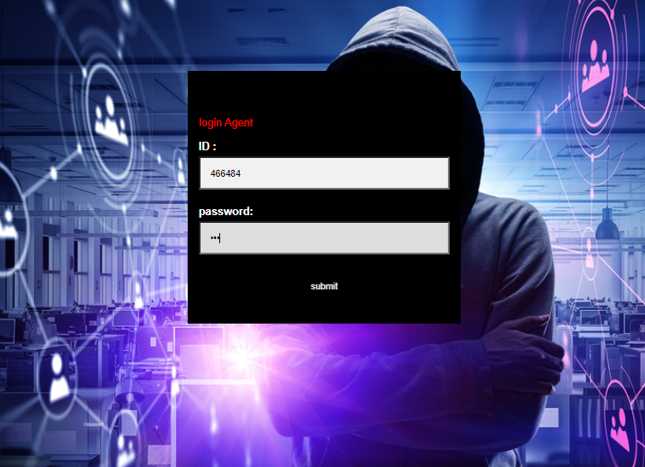

Enter the Agent menu page:

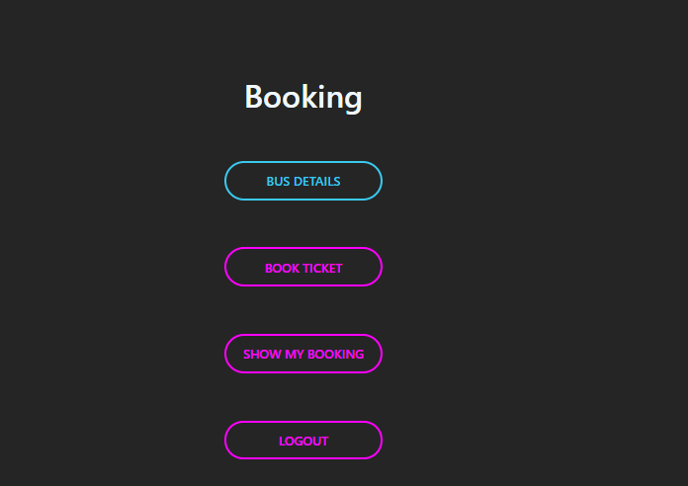

On clicking whole bus details button, displays the bus details as:

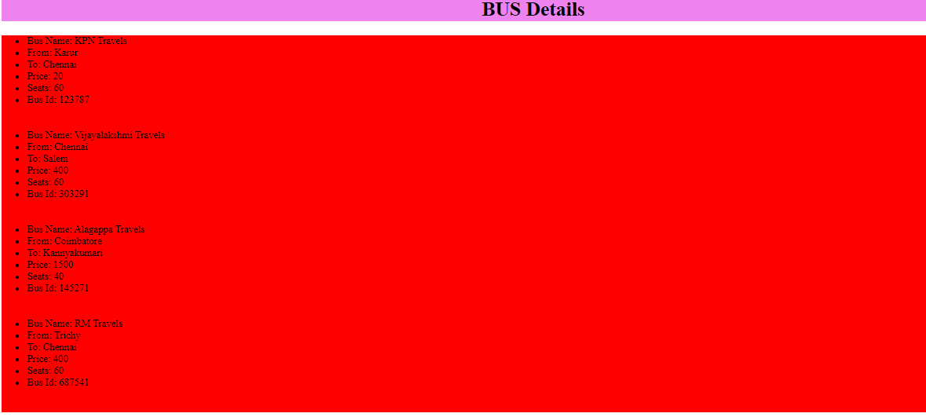

Db details :

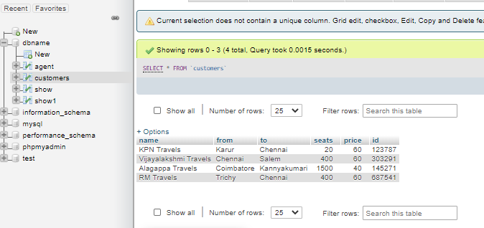

Enter the valid bus id:

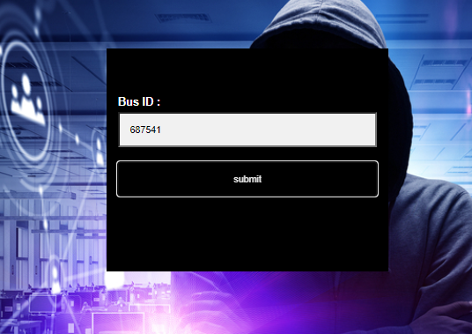

b) If bus id is valid, shows the following details “ Bus Name, From, To , Available

Ticket”.

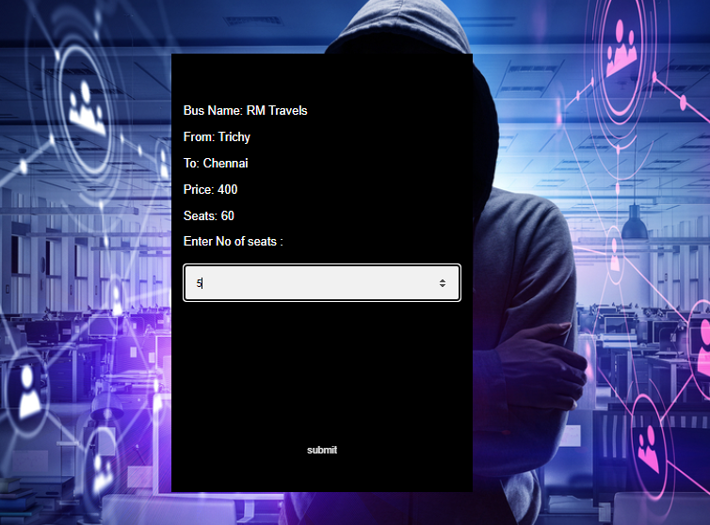

Db details:



c) After successful display of bus details, enter the no of tickets to book



If seats selected greater than the available seats, error is thrown as:

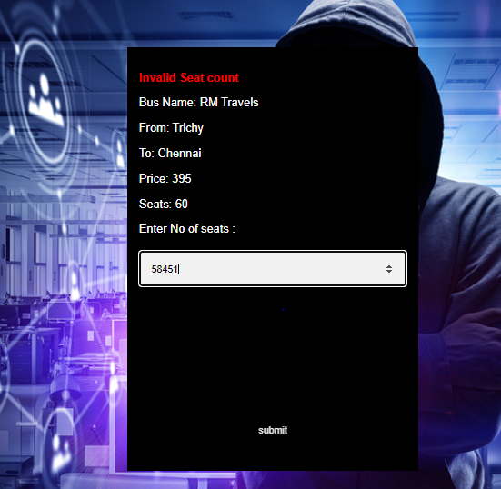

If valid seats are entered, displays the fare and asks to conform booking:

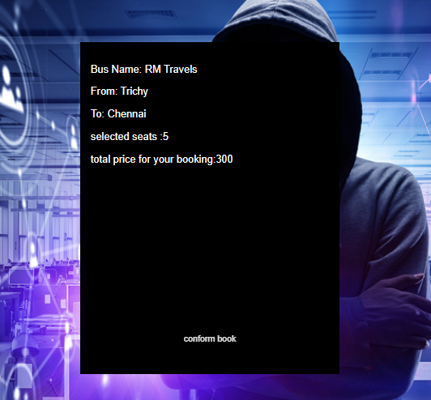

Show My booking for Agents id:

Previously Book Tickets for Agent id – 466484is shown as below:

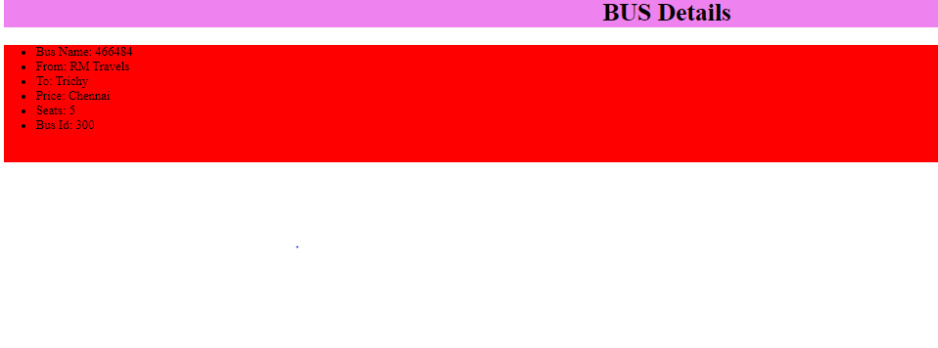

Previously Book Tickets for Agent id – 932471 is shown as below:

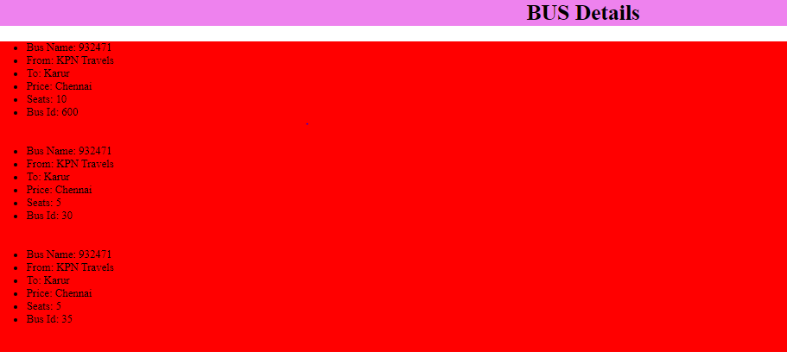

4) Logout

